
JAK2 (R683G)
Catalog Number: CR-M26314
Gene Symbol: JAK2, JTK10, THCYT3
Description: Anti-JAK2 (R683G) Mouse Monoclonal Antibody

Background: JAK2 is a non-receptor tyrosine
kinase. It is a number of the Janus kinase family and has been implicated in ssignaling by
members of the type Ⅱcytokine receptor family, the GM-CSF receptor family, the gp130 receptor family, and the single chain receptors. JAK2
orthologs have been identified in all mammals for which complete genome genome data are
available. Mutations of JAK2 have been
implicated in polycythemia vera, essential
thrombocythemia, and myelofibrosis as well as other myeloproliferative disorders.
Immunogen: A synthetic peptide from the internal region of JAK2 which includes the mutation of R683G, human origin.
Tested applications: ELISA, WB, IHC Recommended dilutions:
ELISA: 1:1000-1:2000
WB: 1:500-1:1000
IHC: 1:50-1:100
Concentration: 0.5 mg/ml
Host: Mouse
Clonality: Monoclonal
Purity: Purified from ascites
Format: Liquid Storage buffer:
Preservative: no
Constituents: PBS (without Mg2+ and Ca2+), pH 7.4, 150 mM NaCl, 50% glycerol
Species Reactivity: Recognizes R683G mutant, but not wild-type JAK2 of vertebrates.
Storage Conditions: Store at -20°C. Avoid freeze / thaw cycles.

Western blot:

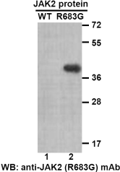

Western blot analysis of recombinant JAK2 (R683G) and wildtype proteins. Purified
His-tagged JAK2 (R683G) protein (lane2) and corresponding wild-type protein (lane1) were blotted with anti-JAK2 (R683G) monoclonal antibody (Cat. #26314).

For research use only. Not for diagnostic or therapeutic applications.

Immunofluorescence:
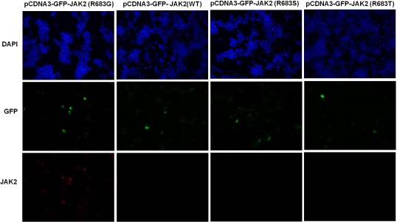
Immunofluorescence of cells expressing JAK2 proteins with anti-JAK2 (R683G) antibody.
HEK293T cells were transfected with pCDNA3-GFP-JAK2 (R683G) plasmid, pCDNA3-GFP-JAK2 (WT) plasmid, pCDNA3-GFP-JAK2 (R683S) plasmid or pCDNA3-GFP-JAK2 (R683T) plasmid, then fixed and stained with anti-JAK2 (R683G) monoclonal antibody (Cat. #26314).

科博瑞（武汉）生物科技有限公司
TEL：027-87615885 15972062685
- mail：3636901710@qq.com
Web:www.coburybio.com

